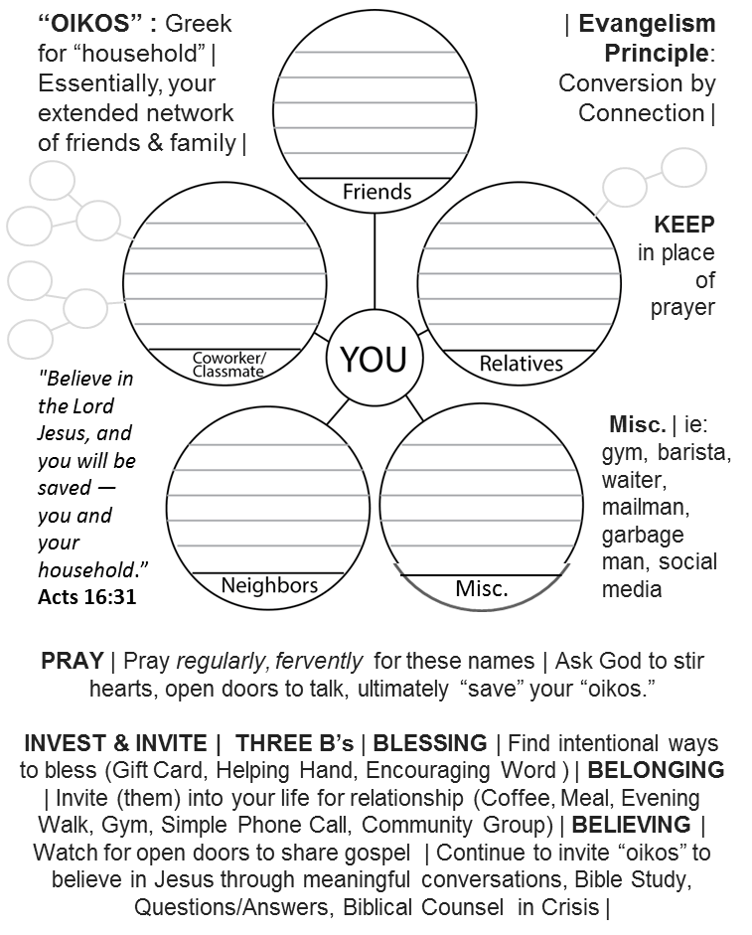
“OIKOS” EVANGELISM TOOL
Lifestyle
Lifestyle

